**7.CREATE A STORAGE SERVICE USING ANY PUBLIC CLOUD SERVICE PROVIDER (AZURE/GCP/AWS) AND CHECK THE PUBLIC ACCESSIBILITY OF THE STORED FILE TO DEMONSTRATE STORAGE AS A SERVICE.**

**AIM:**

**PROCEDURE:**

**STEP1: OPEN AZURE AND GOTO STORAGE ACCOUNTS AND CREATE**

**STOROAGE ACCOUNT**

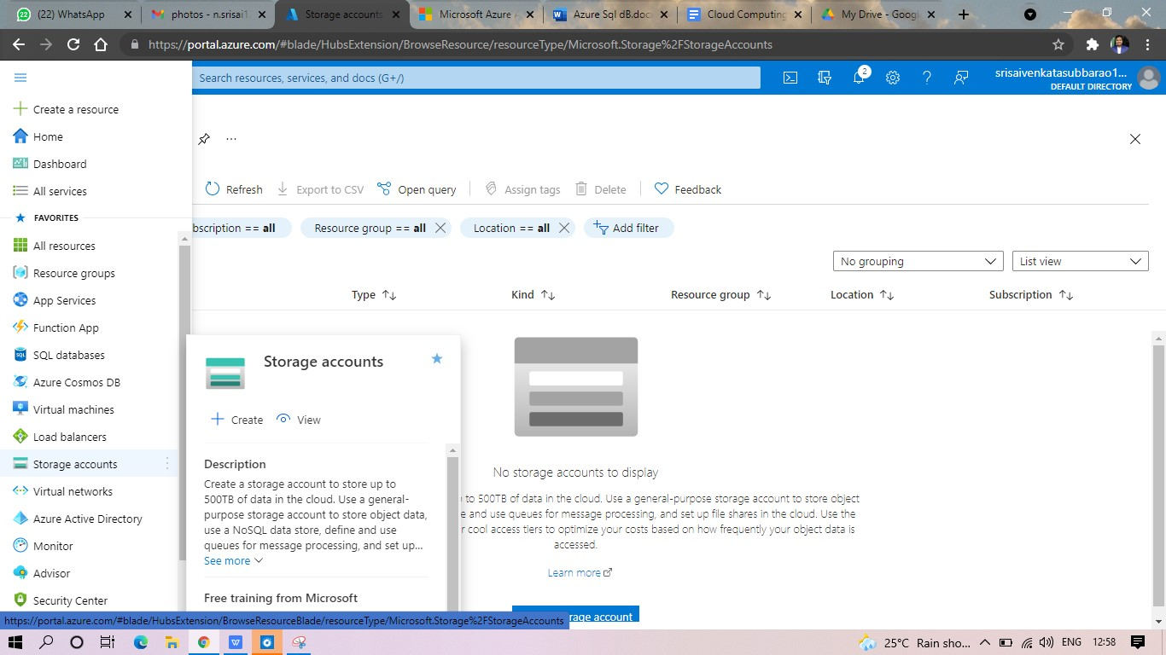

**STEP2: ENTER THE RESOURC GROUP AND AND STORAGE ACCOUNT NAME AND REVIEW AND CREATE AND CLICK TH CREATE AND YOUR STORAGE ACCOUNT WILL BE DEPLOYED SUCESSFULLY.**

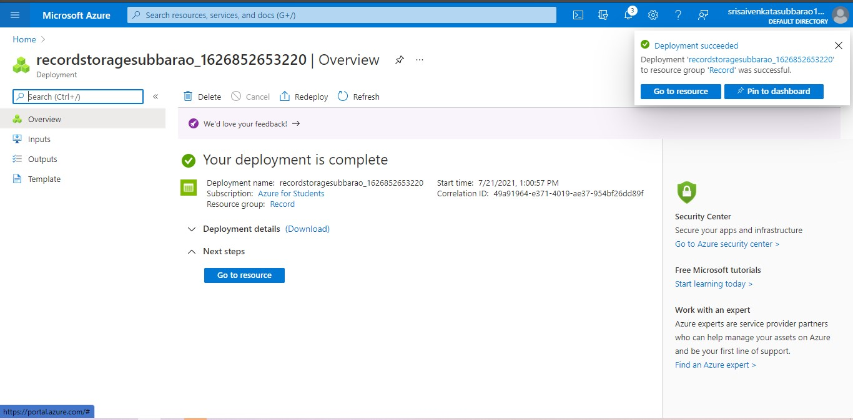

**STP3: AND OUR STORAGE ACCOUNT IS CREATED.**

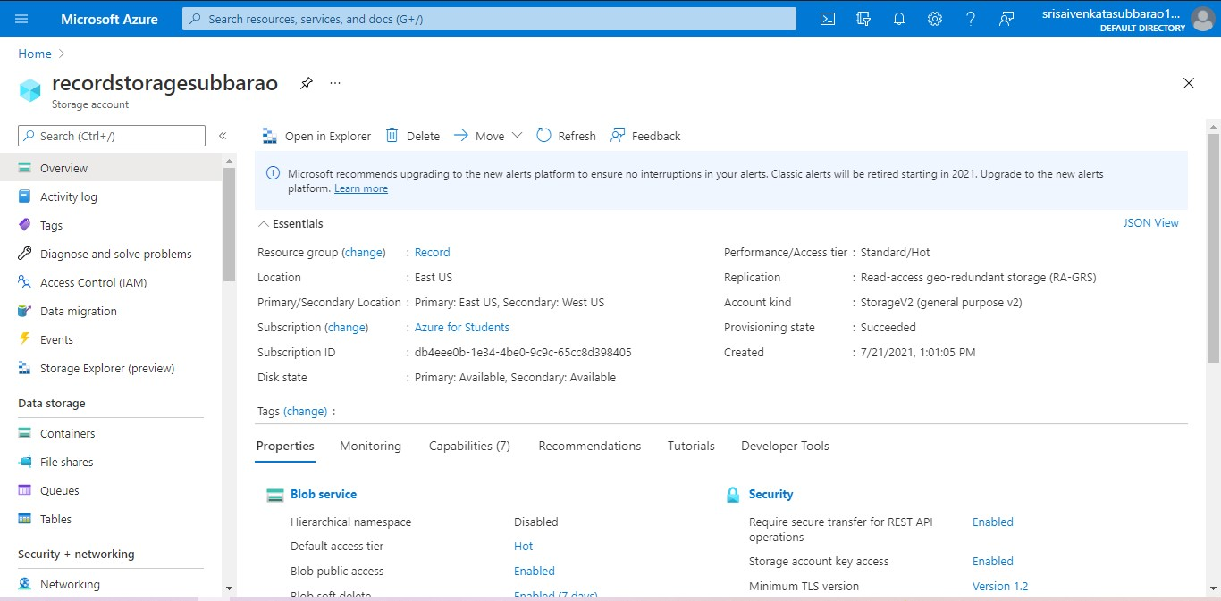

**STEP5: GOTO STATIC WEBSITE**

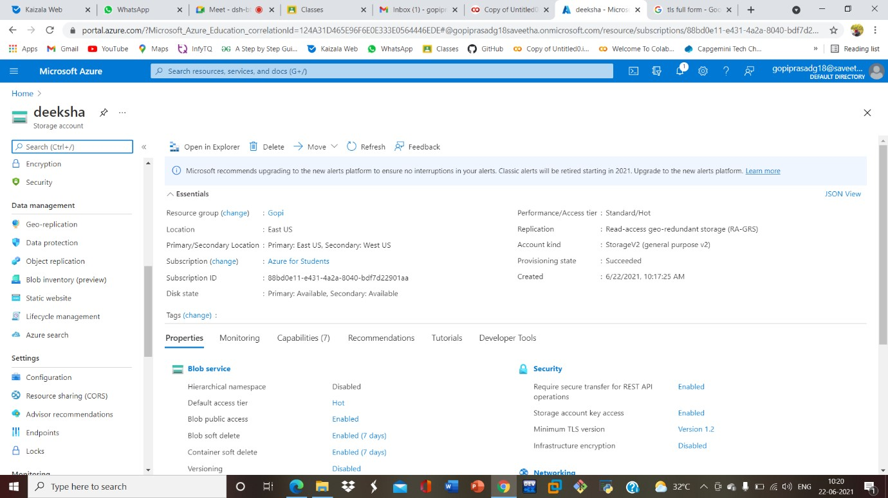

**STEP6: AND ENABLE AND ENTER YOUR INDEX AND ERROR HTML FILESNAMES.**

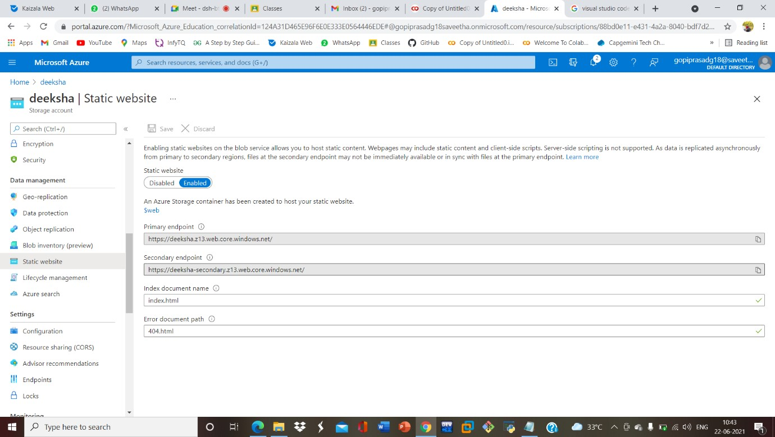

**STEP7: AND GOTO STORAGE EXPLORR(REVIEW) AND AND GOTO BLOB**

**CONTAINERS AND WEB AND UPLOAD THE TWO HTML FILES INIT**

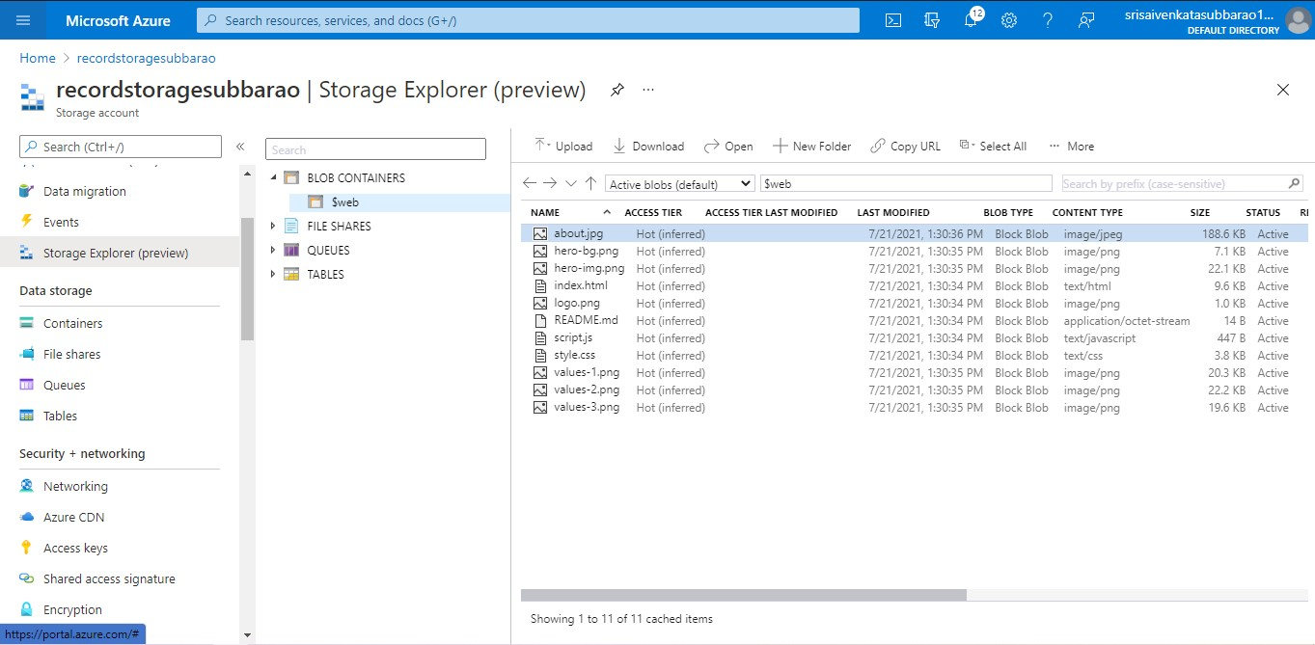

**STEP8: AND AGAIN RETURN TO STATIC WEBSITE AND OPEN THE PRIMARY LINK AND YOUR WEB PAGE IS CREATED**



**RESULT:**